Asset Management
Created for:
Version: | 1.0
Last modification: | 11/14/2018 11:29 AM
Author:
Business entity: | WEBCON Sp. z o.o.
Document status:

Table of contents
1. End-user interface of WEBCON BUSINESS PROCESS SUITE 4
2. Legend 6
3. Asset lifecycle 9
3.1. Graphic workflow presentation 9
3.2. Type of forms and acronyms 9
3.3. Instance number 9
3.4. List of form fields 9
3.5. List of form fields holding personal data 11
3.6. Process-defined privileges 11
3.7. Workflow steps pages: 12
3.7.1. Asset registration 12
3.7.2. Asset available 14
3.7.3. Asset in use 16
3.7.4. Asset out of use 18
3.8. Integration 20
4. Receipt confirmation 21
4.1. Graphic workflow presentation 21
4.2. Type of forms and acronyms 21
4.3. Instance number 21
4.4. List of form fields 21
4.5. List of form fields holding personal data 22
4.6. Process-defined privileges 22
4.7. Workflow steps pages: 23
4.7.1. Asset assignment registration 23
4.7.2. Receipt confirmation 24
4.7.3. Asset received 26
4.7.4. Asset assignment cancelled 27
4.8. Integration 28
5. Return confirmation 29
5.1. Graphic workflow presentation 29
5.2. Type of forms and acronyms 29
5.3. Instance number 29
5.4. List of form fields 29
5.5. List of form fields holding personal data 30
5.6. Process-defined privileges 30
5.7. Workflow steps pages: 31
5.7.1. Asset return registration 31
5.7.2. Return confirmation 33
5.7.3. Asset returned 34
5.8. Integration 36
6. Constants 37
6.1. Local constants 37
6.2. Global constants 37
7. Business rules 38
7.1. Local business rules 38
7.1.1. Business rules 38
7.1.2. Form rules 38
7.2. Global business rules 38
7.2.1. Business rules 38
7.2.2. Form rules 38
8. Action templates 39

End-user interface of WEBCON BUSINESS PROCESS SUITE
The end-user interface of WEBCON Business Process Suite inherits styles already used in Microsoft SharePoint. The image below presents the design and location of certain interface elements:
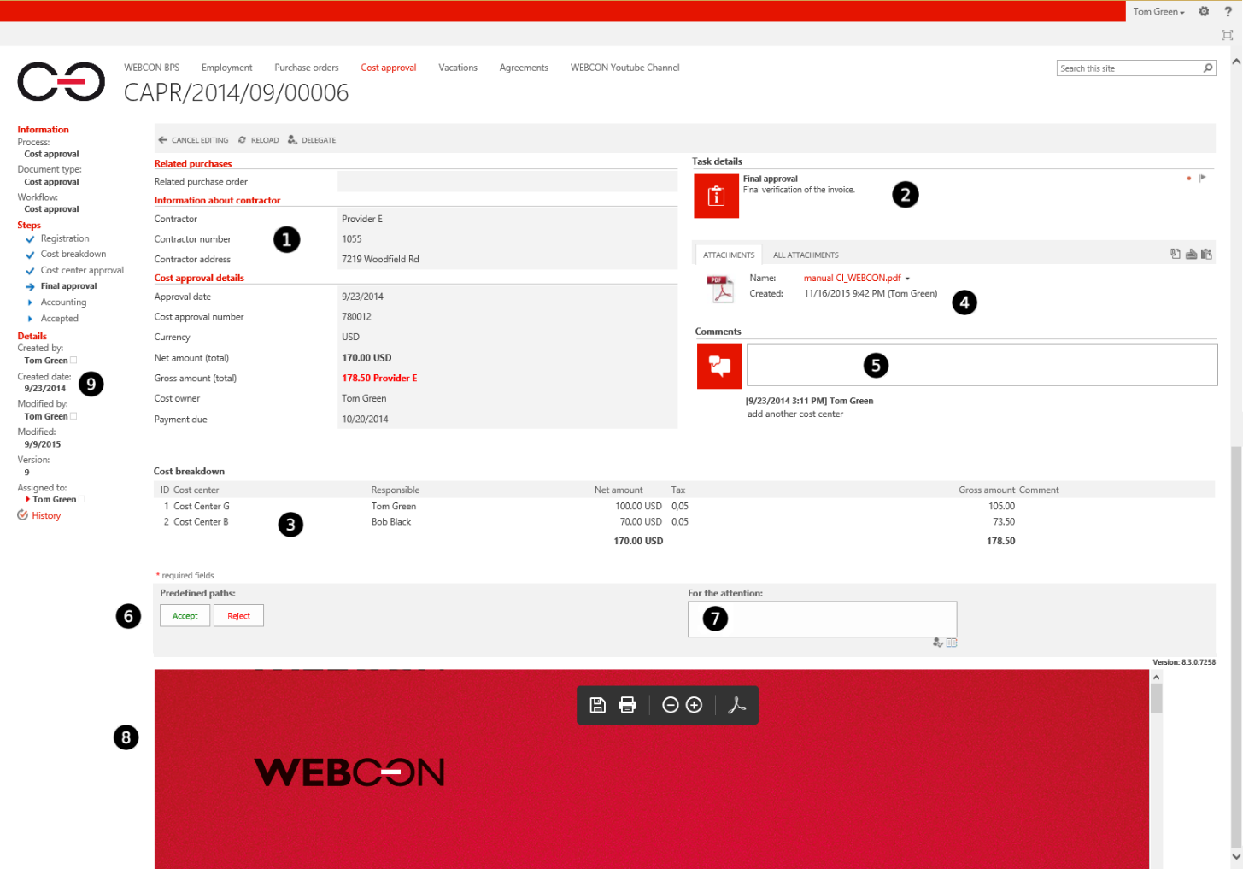
❶ Left form field panel
Contains form fields defined for a given step of the workflow. It is possible to set the order, default values and parameters (ability to edit, read-only, required) of all available fields.
❷ Right form field panel
Contains form fields defined for a given step of the workflow. It is possible to set the order, default values and parameters (ability to edit, read-only, required) of all available fields.
❸ Lower form field panel
Contains ‘Item list’ and ‘Multiple lines of text’ type form fields defined for a given step of the workflow. It is possible to set the order, default values and parameters (ability to edit, read-only, required) of all available fields.

❹ Attachment area
This is where all files attached to a workflow are accessible. Attachments can be added manually by a user who chooses a file from their hard drive, through WEBCON BPS actions, or by invoking TWAIN driver of a scanner attached to user’s computer (system allows to automatically attach files with WEBCON BPS barcode). It is possible to preview attachments (more in pt. 8), download them or remove from the workflow (those options are regulated accordingly to a users’ permissions).
❺ Comment section
Contains text comments which users enter during workflow activity. Comments are presented chronologically, with the newest one at the top.
❻ Transition path area
Contains all transition paths that a workflow instance can take on a given step of the workflow. By clicking one of these path buttons, the workflow instance will transition to the step designated by the selected path.
❼ CC Area
Choose additional users that will be notified as recipients for CC tasks.
❽ Attachment preview section
Used for previewing attachments. In order to preview files, the end user has to have certain plugins installed that handle the previewing of certain files in Internet Explorer (e.g. Adobe Acrobat Reader for PDF files).
❾ Information section
Contains information about the current workflow instance, such as:
- Process, form type and workflow
- Which step of the workflow it is on, which steps’ tasks have already been completed.
- Author of the workflow instance, creation date, last modification date, user who performed the last modification
Every user with administrative privileges also has access to the detailed history of each workflow instance

Legend
Name | Description
WEBCON Business Process Suite (WEBCON BPS) | WEBCON Business Process Suite is a comprehensive solution for Microsoft SharePoint allowing to effectively manage business processes and documents in any organization.
Process | A process in WEBCON BPS is a way to define complete business process in a company. Its main components are workflows, form fields and form types.
Workflow | Workflow defines business logic and all rules of given business process. Each process can consist of several workflows, e.g. correspondence process may contain incoming and outgoing correspondence workflow.
Form type | Content and details of form that will be registered for a given workflow e.g.:  - Leave of absence request  - Requisition form
Form fields | Form fields represent metadata in a form and are available for all workflows defined under one business process definition. A sample field may contain data such as: vendor name, date of registration of a form, analytical breakdown of an invoice, etc.
Step | A stage/status of workflow instance describing in which part of a processes certain instance currently is. E.g:  - Registration  - Approval  - Archive
Transition path | A connection between two steps. Once it’s clicked, it usually also changes the status of the workflow instance as it proceeds to another step.
Workflow participants | Users that take part in a process, e.g.  - Workflow initiator  - Approver  - Supervisor
Task | An element allowing to indicate a person (or group of people) which should take an action in order for workflow to proceed to another step. A task is visible on a form, in Information section (9).
SharePoint – SPS / SP | A platform which is basic element allowing WEBCON BPS to function. SharePoint is used to build sites, lists, groups, etc.
SharePoint list | Element of SharePoint site allowing to create data sources.  For instance:  - List of absence types  - List of holidays
SharePoint Group | SharePoint users Group. Groups can be used to grant privileges for processes and reports.
SWE (Show Workflow Elements) Report | Report allowing to display all workflow instances in a database for each business process defined in WEBCON BPS Designer Studio. Report displays those instances, to which currently logged-in user has viewing privileges.
Technical fields | Fields used to create certain functionalities. Usually displayed only to system administrators.
Global fields | Fields allowing to save data (e.g. vendor VAT ID) to one field that would be available for use in multiple processes.
Active Directory (AD) | Cataloging service for Windows system that keeps information about users (AD login, AD group, company structure)
AD Group | Group of users in Active Directory. Groups can be used to grant privileges for processes and reports.
User’s login | Unique identifier defining a user in domain.  For instance: DOMAIN\j.doe  Login is a unique identifier of user in workflow.
User privileges – Administration | User with such privileges has access to each workflow instance registered within given business process. Such workflow instance can be edited by user, regardless of step in which workflow is. Additionally, users with administration privileges can delete instances from the system (although it’s not recommended). They have access to history of all instances (including technical fields).
User privileges – Modification (can’t delete) | User with such privileges has access to each workflow instance registered in the system in particular process. Such workflow instance can be edited by user, regardless of step in which workflow instance is.
User privileges – starting new workflow | User with such privileges can register new instances in the system for particular process.
User privileges – Read-only | User with such privilege can access all instances registered in the system for particular process, but only in read-only mode. User can only edit Comment field.
User privileges – Read-only (can’t view attachments) | User with such privilege can access all instances registered in the system for particular process, but only in read-only mode. User can only edit Comment field. This privilege does NOT allow to view attachments added to a workflow instances.
Action | In WEBCON BPS it is possible to define various types of actions on each step and transition path (e.g. to: calculate values, validate fields, add privileges, etc.)  In WEBCON BPS, the execution of an action can be triggered by the following events (description below):
Action on entry | On entry – a state when workflow instance proceeds to destination step after going through transition path.
Action on exit | On exit – a state when workflow instance exits certain step and then proceed with transition path.
Action on path | On path – during transition between steps.
Action on timeout | On timeout – action executed cyclically for given instance. Execution cycle (timeout) can be defined accordingly to user’s requirements.
Cyclical action | On start (cyclical) – action executed cyclically, not related to a particular instance (e.g. allows to start new workflows). Frequency can be configured accordingly to requirements.
Action on browser opening | On browser opening – a state when user opens an instance in internet browser and has task assigned in opened instance (or is substituting person to which a task was originally assigned).
Action on menu button | Menu button – action is executed manually by pressing a button available on a form, once workflow instance is opened in internet browser.
Action on element deleting | On element deleting – action is executed once workflow instance is removed from the system.
Action on element saving | On element saving – action is executed when user presses “Save” button available on a form.

Asset lifecycle
It is one of three workflows dedicated to IT equipment management. It provides the form to register all assets in use - to be assigned or returned using the other two workflows.

Graphic workflow presentation
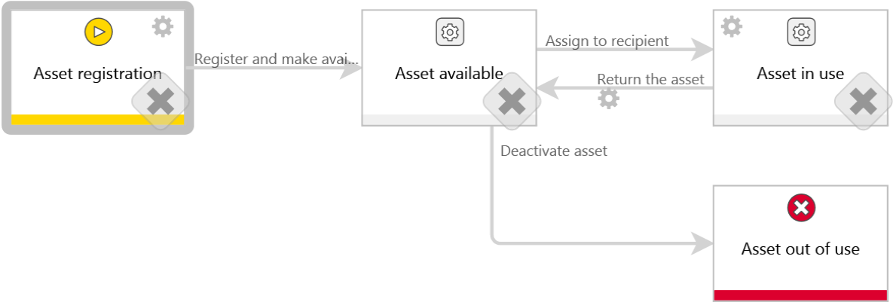

Type of forms and acronyms
Acronym | Name | Description | Documentation
ASSET | Asset card

Instance number
Instance number cannot be changed after document registration. If form type has an instance number defined, it will be displayed on the form, regardless of document number’s configuration on workflow.
Automatically generated by the system according to the scheme:
{NUMBER:5}-{I:158}-{YEAR}

Bus. - Business rule
Form. - Form rule

List of form fields
Name | Form field type | Description for user | Decription for documentation | Business rules
Asset details | Group of form fields
Serial number | Single line of text | Enter the serial number.
Asset type | Choice field | Choose a type of asset.
Manufacturer | Choice field | Choose the manufacturer. | To filter manufacturers list by chosen asset type use the CAML query below within the datasource config.  <Where>  <Eq>  <FieldRef Name="[use_column_name_from_your_lookup_column_in_manufacturers_list]" />  <Value Type="LookupMulti">{N:[use_id_of_ASSET_TYPE_FIELD]}</Value>  </Eq>  </Where>
Asset name | Single line of text | Name is given automatically based on the serial number, type and manufacturer.
Hostname | Single line of text
Description | Single line of text | Provide description if needed.
IT Owner | Person or group | Person responsible for this type of asset within the IT department.
Assignment | Group of form fields
Currently assigned to | Person or group | Current end-user assigned to the asset.
Current location | Data row | Current location of this asset.
Current location
Additional information | Group of form fields
Purchase date | Date | Select a purchase date.
Service TAG | Single line of text | Service TAG - if available.
Inventory account number | Single line of text | A number identyfying an asset in inventory register.
Value | Floating-point number | Value of this asset.
Parameters | Multiple lines of text | Please provide technical parameters if available.
IT comments | Multiple lines of text | For IT details, visibility only for IT
Warranty details | Group of form fields
Warranty | Yes / No choice | Check if warranty is available.
Warranty till | Date | End date of warranty.
Reports | Group of form fields
Receipt confirmations and returns of the asset | Data table |  | Only visible for an asset card.
Document
End-user
Date
Location

List of form fields holding personal data
No form fields holding personal data.

Process-defined privileges
Privileges per process:
Business entity | Administration | Modification (can't delete) | Add new | Read-only | Read-only (can't view attachments)
General | Zimmermann, Ingo (ADM) | Leweling, Manfred | Zimmermann, Ingo (ADM) | Hüffer, Bernd
General | Kraft, Jan-Arno (ADM) |  | Zimmermann, Ingo | Ulbrich, Uwe
General |  |  | Kraft, Jan-Arno
General |  |  | Kraft, Jan-Arno (ADM)
General |  |  | Leweling, Manfred

Privileges per form type -Asset card
Business entity | Administration | Modification (can't delete) | Add new | Read-only | Read-only (can't view attachments)

Additional privileges can be granted using an action to add privileges based on workflow configuration. Description of those actions is available in action tables.

Workflow steps pages:

Asset registration

Business rules on step
Bus. - Business rule
Form. - Form rule
Business rules
Standard form
Mobile form
User fills in all the required information including category of equipment. After registering the equipment is ready to use (asignement) within receipt workflow.

Form fields available on the step "1. Asset registration"

Vis. - visible on form  Rea. - read-only field  Req. - required field | Field that hasn’t changed.  Field which behavior mode (read-only/ required) has changed, or has been hidden on this step (X).  Field which visibility has changed to visible.

Bus. - Business rule
Form. - Form rule
Left panel
Name | Type | [Vis.] | [Rea.] | [Req.] | Business rules
Asset details | Group of form fields | P
Serial number | Single line of text | P |  | P
Asset type | Choice field | P |  | P
Manufacturer | Choice field | P |  | P
Asset name | Single line of text | P | P | P
Hostname | Single line of text | P
Description | Single line of text | P
IT Owner | Person or group | P
Assignment | Group of form fields | O | O | O
Currently assigned to | Person or group | O | O | O
Current location | Data row | O | O | O
Additional information | Group of form fields | P
Purchase date | Date | P
Service TAG | Single line of text | P
Inventory account number | Single line of text | P
Value | Floating-point number | P
Parameters | Multiple lines of text | P
IT comments | Multiple lines of text | P
Warranty details | Group of form fields | P
Warranty | Yes / No choice | P
Warranty till | Date | P

Right panel
Name | Type | [Vis.] | [Rea.] | [Req.] | Business rules
Reports | Group of form fields | O | O | O
Receipt confirmations and returns of the asset | Data table | O | O | O

Transition paths on step "1. Asset registration"
Name | Description | Next step | Tasks | Business rules
Save & continue | Path allows to save a form with asset description for further processing. | 1. Asset registration | Based on Configuration:  - Pass to author
Register and make available | Path advances to the 'Asset in use' workflow step. | 2. Asset available | NONE

Actions on the step "1. Asset registration"
Action trigger | Name | Type | Description | Business rules
On exit | Add privileges to modify asset card | Add privileges | IT department gets possibility to modify some of the fields describing the asset.

Asset available

Business rules on step
Bus. - Business rule
Form. - Form rule
Business rules
Standard form
Mobile form
All equipment within this step is available for assigning to employees within receipt workflow.

Form fields available on the step "2. Asset available"

Vis. - visible on form  Rea. - read-only field  Req. - required field | Field that hasn’t changed.  Field which behavior mode (read-only/ required) has changed, or has been hidden on this step (X).  Field which visibility has changed to visible.

Bus. - Business rule
Form. - Form rule
Left panel
Name | Type | [Vis.] | [Rea.] | [Req.] | Business rules
Asset details | Group of form fields | P
Serial number | Single line of text | P | P
Asset type | Choice field | O | O | O
Manufacturer | Choice field | O | O | O
Asset name | Single line of text | P | P
Hostname | Single line of text | P
Description | Single line of text | P
IT Owner | Person or group | P |  | P
Assignment | Group of form fields | O | O | O
Currently assigned to | Person or group | O | O | O
Current location | Data row | O | O | O
Additional information | Group of form fields | P
Purchase date | Date | P
Service TAG | Single line of text | P
Inventory account number | Single line of text | P
Value | Floating-point number | P
Parameters | Multiple lines of text | P
IT comments | Multiple lines of text | P
Warranty details | Group of form fields | P
Warranty | Yes / No choice | P
Warranty till | Date | P

Right panel
Name | Type | [Vis.] | [Rea.] | [Req.] | Business rules
Reports | Group of form fields | P
Receipt confirmations and returns of the asset | Data table | P

Transition paths on step "2. Asset available"
Name | Description | Next step | Tasks | Business rules
Deactivate asset | Path is used to move the asset to "Asset out of use step" and make it unavailable for further assignment. | 4. Asset out of use | NONE
Update information | Updates the information on a form. | 2. Asset available | NONE
Assign to recipient | This is a technical path to move workflow do the next step. It is beeing triggered by the Receipt confirmation workflow. It is not available on a form for end-users.  Path not visible on standard form | 3. Asset in use | NONE

Actions on the step "2. Asset available"
Action trigger | Name | Type | Description | Business rules
Menu button | Assign this asset to user | Action button | This action allow to create new receipt document. | (...)
Menu button | Assign this asset to user | Hyperlink | This action allow to create new receipt document.
Menu button | Clone asset | Action button | This action allow to clone this asset.
Menu button | Clone asset | Hyperlink | This action allow to clone this asset.

Asset in use

Business rules on step
Bus. - Business rule
Form. - Form rule
Business rules
Standard form
Mobile form
All equipment currently assigned to employees is listed in this step. Only equipment listed here can be used with return workflow.

Form fields available on the step "3. Asset in use"

Vis. - visible on form  Rea. - read-only field  Req. - required field | Field that hasn’t changed.  Field which behavior mode (read-only/ required) has changed, or has been hidden on this step (X).  Field which visibility has changed to visible.

Bus. - Business rule
Form. - Form rule
Left panel
Name | Type | [Vis.] | [Rea.] | [Req.] | Business rules
Asset details | Group of form fields | P
Serial number | Single line of text | P | P
Asset type | Choice field | O | O | O
Manufacturer | Choice field | O | O | O
Asset name | Single line of text | P | P
Hostname | Single line of text | P | P
Description | Single line of text | P
IT Owner | Person or group | P | P
Assignment | Group of form fields | P
Currently assigned to | Person or group | P | P
Current location | Data row | P
Additional information | Group of form fields | P
Purchase date | Date | P
Service TAG | Single line of text | P
Inventory account number | Single line of text | P
Value | Floating-point number | P
Parameters | Multiple lines of text | P
IT comments | Multiple lines of text | P
Warranty details | Group of form fields | P
Warranty | Yes / No choice | P
Warranty till | Date | P

Right panel
Name | Type | [Vis.] | [Rea.] | [Req.] | Business rules
Reports | Group of form fields | P
Receipt confirmations and returns of the asset | Data table | P

Transition paths on step "3. Asset in use"
Name | Description | Next step | Tasks | Business rules
Return the asset | This is a technical path to move workflow do the next step.  Path not visible on standard form | 2. Asset available | NONE | (...)
Update information | Updates the information on a form. | 3. Asset in use | NONE

Actions on the step "3. Asset in use"
Action trigger | Name | Type | Description | Business rules
On entry | Add read-only (without attachments) right to end-u | Add privileges
Menu button | Return the asset | Action button |  | (...)
Menu button | Return the asset | Hyperlink
Menu button | Clone asset | Action button
Menu button | Clone asset | Hyperlink
On path: Return the asset | Clear the current user (return) | Change value of single field | Clears the current user upon return of the asset.

Asset out of use

Business rules on step
Bus. - Business rule
Form. - Form rule
Business rules
Standard form
Mobile form
This step indicates that equipment is no longer used.

Form fields available on the step "4. Asset out of use"

Vis. - visible on form  Rea. - read-only field  Req. - required field | Field that hasn’t changed.  Field which behavior mode (read-only/ required) has changed, or has been hidden on this step (X).  Field which visibility has changed to visible.

Bus. - Business rule
Form. - Form rule
Left panel
Name | Type | [Vis.] | [Rea.] | [Req.] | Business rules
Asset details | Group of form fields | P
Serial number | Single line of text | P | P
Asset type | Choice field | O | O | O
Manufacturer | Choice field | O | O | O
Asset name | Single line of text | P | P
Hostname | Single line of text | O | O | O
Description | Single line of text | P | P
IT Owner | Person or group | O | O | O
Assignment | Group of form fields | O | O | O
Currently assigned to | Person or group | O | O | O
Current location | Data row | O | O | O
Additional information | Group of form fields | P | P
Purchase date | Date | P | P
Service TAG | Single line of text | P | P
Inventory account number | Single line of text | P | P
Value | Floating-point number | P | P
Parameters | Multiple lines of text | P | P
IT comments | Multiple lines of text | P | P
Warranty details | Group of form fields | P
Warranty | Yes / No choice | P | P
Warranty till | Date | P | P

Right panel
Name | Type | [Vis.] | [Rea.] | [Req.] | Business rules
Reports | Group of form fields | P
Receipt confirmations and returns of the asset | Data table | P

Actions on the step "4. Asset out of use"
Action trigger | Name | Type | Description | Business rules
Menu button | Clone asset | Action button
Menu button | Clone asset | Hyperlink

Integration
Data sources:
Form field / Column | Data source name | Source type
Asset type | IT Assets - asset types | SharePoint list
Manufacturer | IT Assets - manufacturers | SharePoint list

Connections:
Form field / Column | Data connection name | Source type
Additional information | <Current BPS database> | System
Asset details | <Current BPS database> | System
Warranty details | <Current BPS database> | System
Assignment | <Current BPS database> | System
Reports | <Current BPS database> | System
Current location | <Current BPS database> | System
Receipt confirmations and returns of the asset | <Current BPS database> | System

Receipt confirmation
It is one of three workflows dedicated to IT equipment management. It provides the form toassign asset to the end-user.

Graphic workflow presentation
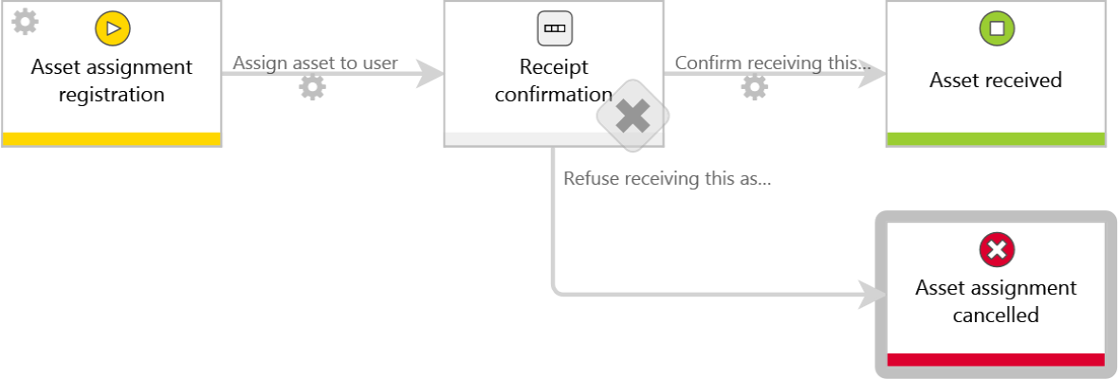

Type of forms and acronyms
Acronym | Name | Description | Documentation
OUT | Receipt Form

Instance number
Instance number cannot be changed after document registration. If form type has an instance number defined, it will be displayed on the form, regardless of document number’s configuration on workflow.
Automatically generated by the system according to the scheme:
{NUMBERINYEAR:4}-{DTYPE_Acronym}-{YEAR}

Bus. - Business rule
Form. - Form rule

List of form fields
Name | Form field type | Description for user | Decription for documentation | Business rules
Asset details | Group of form fields
Name | Choice field | Choose an asset to receive / return. | Field allows to choose an asset to assign within receipt workflow, or return. It lists all of the assets that are currently within the 'available' or 'in use' steps of the 'registration' workflow. Picker search is configured to allow searching through an ID, name, serial number or a service tag.
Hostname | Single line of text
Asset information | Data row
Link
Manufacturer
Description
Parameters
Inventory number
Serial number
Service TAG
Purchased in
Assignment | Group of form fields
Asset user | Person or group | Person to whom asset will be / is asigned to.
Location | Single line of text | Current location of this asset.
Reports | Group of form fields
Assigned assets | Data table | List of assets assigned to the user. | Only available for the receipt / return workflows.
Asset number
Asset name
Description
Purchased in

List of form fields holding personal data
No form fields holding personal data.

Process-defined privileges
Privileges per process:
Business entity | Administration | Modification (can't delete) | Add new | Read-only | Read-only (can't view attachments)
General | Zimmermann, Ingo (ADM) | Leweling, Manfred | Zimmermann, Ingo (ADM) | Hüffer, Bernd
General | Kraft, Jan-Arno (ADM) |  | Zimmermann, Ingo | Ulbrich, Uwe
General |  |  | Kraft, Jan-Arno
General |  |  | Kraft, Jan-Arno (ADM)
General |  |  | Leweling, Manfred

Privileges per form type -Receipt Form
Business entity | Administration | Modification (can't delete) | Add new | Read-only | Read-only (can't view attachments)

Additional privileges can be granted using an action to add privileges based on workflow configuration. Description of those actions is available in action tables.

Workflow steps pages:

Asset assignment registration

Business rules on step
Bus. - Business rule
Form. - Form rule
Business rules
Standard form
Mobile form
Only IT department employees are able to start this workflow. After selecting the assed and desired end user workflow proceeds to the next step.

Form fields available on the step "1. Asset assignment registration"

Vis. - visible on form  Rea. - read-only field  Req. - required field | Field that hasn’t changed.  Field which behavior mode (read-only/ required) has changed, or has been hidden on this step (X).  Field which visibility has changed to visible.

Bus. - Business rule
Form. - Form rule
Left panel
Name | Type | [Vis.] | [Rea.] | [Req.] | Business rules
Asset details | Group of form fields | P
Name | Choice field | P
Hostname | Single line of text | P | P
Asset information | Data row | P
Assignment | Group of form fields | P
Asset user | Person or group | P |  | P
Location | Single line of text | P

Right panel
Name | Type | [Vis.] | [Rea.] | [Req.] | Business rules
Reports | Group of form fields | O | O | O
Assigned assets | Data table | O | O | O

Transition paths on step "1. Asset assignment registration"
Name | Description | Next step | Tasks | Business rules
Assign asset to user | Path is used to assign selected asset to selected end-user. E-mail notification is sent automatically. | 2. Receipt confirmation | Based on attribute :  - Asset user

Actions on the step "1. Asset assignment registration"
Action trigger | Name | Type | Description | Business rules
On entry | check if asset is not beeing received already | Validate form
On path: Assign asset to user | Modification for [Recipient] | Add privileges
On path: Assign asset to user | E-mail notification to the user | Send a custom email | Email sent only if currently logged in user is not the asset user. | Bus. Current user is not ASSET user

Receipt confirmation

Business rules on step
Bus. - Business rule
Form. - Form rule
Business rules
Standard form
Mobile form
Task is assigned to the end user. He inputs the location and confirms receiving the asset. Refusal is also possible - after filling in the comment field the form returns to the author.

Form fields available on the step "2. Receipt confirmation"

Vis. - visible on form  Rea. - read-only field  Req. - required field | Field that hasn’t changed.  Field which behavior mode (read-only/ required) has changed, or has been hidden on this step (X).  Field which visibility has changed to visible.

Bus. - Business rule
Form. - Form rule
Left panel
Name | Type | [Vis.] | [Rea.] | [Req.] | Business rules
Asset details | Group of form fields | P
Name | Choice field | P | P
Hostname | Single line of text | P | P
Asset information | Data row | P
Assignment | Group of form fields | P
Asset user | Person or group | P | P
Location | Single line of text | P |  | P

Right panel
Name | Type | [Vis.] | [Rea.] | [Req.] | Business rules
Reports | Group of form fields | P
Assigned assets | Data table | P

Transition paths on step "2. Receipt confirmation"
Name | Description | Next step | Tasks | Business rules
Confirm receiving this asset | This path allows to confirm registration and finish the workflow. It triggers moving the asset to "Asset in use" step of the "Asset registration" workflow, and updates the asset card with the information about the currently assigned end-user. The workflow ends (positive finish). | 3. Asset received | NONE
Refuse receiving this asset | This path allows to refuse asset assignment. Comment is required. IT department (author) is notified by email. The workflow is over (negative finish). | 4. Asset assignment cancelled | NONE

Actions on the step "2. Receipt confirmation"
Action trigger | Name | Type | Description | Business rules
On path: Confirm receiving this asset | Add the possibility to edit the form later on | Add privileges
On path: Confirm receiving this asset | Update asset register | Move workflow (SQL)

Asset received

Business rules on step
Bus. - Business rule
Form. - Form rule
Business rules
Standard form
Mobile form
The asset is assigned to the end user and the workflow is completed.

Form fields available on the step "3. Asset received"

Vis. - visible on form  Rea. - read-only field  Req. - required field | Field that hasn’t changed.  Field which behavior mode (read-only/ required) has changed, or has been hidden on this step (X).  Field which visibility has changed to visible.

Bus. - Business rule
Form. - Form rule
Left panel
Name | Type | [Vis.] | [Rea.] | [Req.] | Business rules
Asset details | Group of form fields | P
Name | Choice field | P | P
Hostname | Single line of text | P | P
Asset information | Data row | P
Assignment | Group of form fields | P
Asset user | Person or group | P | P
Location | Single line of text | P | P

Right panel
Name | Type | [Vis.] | [Rea.] | [Req.] | Business rules
Reports | Group of form fields | P
Assigned assets | Data table | P

Asset assignment cancelled

Business rules on step
Bus. - Business rule
Form. - Form rule
Business rules
Standard form
Mobile form
Assignment has been canceled and the workflow is over.

Form fields available on the step "4. Asset assignment cancelled"

Vis. - visible on form  Rea. - read-only field  Req. - required field | Field that hasn’t changed.  Field which behavior mode (read-only/ required) has changed, or has been hidden on this step (X).  Field which visibility has changed to visible.

Bus. - Business rule
Form. - Form rule
Left panel
Name | Type | [Vis.] | [Rea.] | [Req.] | Business rules
Asset details | Group of form fields | P | P
Name | Choice field | P | P
Hostname | Single line of text | P | P
Asset information | Data row | P
Assignment | Group of form fields | P
Asset user | Person or group | P | P
Location | Single line of text | P | P

Right panel
Name | Type | [Vis.] | [Rea.] | [Req.] | Business rules
Reports | Group of form fields | P
Assigned assets | Data table | P

Integration
Connections:
Form field / Column | Data connection name | Source type
Asset details | <Current BPS database> | System
Reports | <Current BPS database> | System
Assignment | <Current BPS database> | System
Assigned assets | <Current BPS database> | System
Name | <Current BPS database> | System
Asset information | <Current BPS database> | System

Return confirmation
It is one of three workflows dedicated to IT equipment management. It provides the form to return assets that are not used anymore.

Graphic workflow presentation
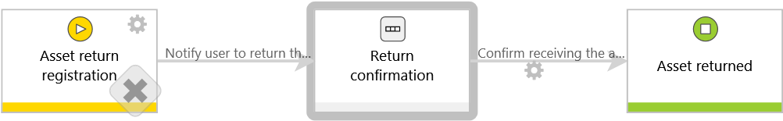

Type of forms and acronyms
Acronym | Name | Description | Documentation
IN | Return Form

Instance number
Instance number cannot be changed after document registration. If form type has an instance number defined, it will be displayed on the form, regardless of document number’s configuration on workflow.
Automatically generated by the system according to the scheme:
{NUMBERINYEAR:4}-{DTYPE_Acronym}-{YEAR}

Bus. - Business rule
Form. - Form rule

List of form fields
Name | Form field type | Description for user | Decription for documentation | Business rules
Asset details | Group of form fields
Name | Choice field | Choose an asset to receive / return. | Field allows to choose an asset to assign within receipt workflow, or return. It lists all of the assets that are currently within the 'available' or 'in use' steps of the 'registration' workflow. Picker search is configured to allow searching through an ID, name, serial number or a service tag.
Asset type | Choice field | Choose a type of asset.
Hostname | Single line of text
Asset information | Data row
Link
Manufacturer
Description
Parameters
Inventory number
Serial number
Service TAG
Purchased in
IT Owner | Person or group | Person responsible for this type of asset within the IT department.
IT Comment | Multiple lines of text | This comment is only visible for the IT department.
Assignment | Group of form fields
Asset user | Person or group | Person to whom asset will be / is asigned to.
Location | Single line of text | Current location of this asset.
Return reason | Choice field | Provide a reason of returning an asset.
Reports | Group of form fields
Assigned assets | Data table | List of assets assigned to the user. | Only available for the receipt / return workflows.
Asset number
Asset name
Description
Purchased in

List of form fields holding personal data
No form fields holding personal data.

Process-defined privileges
Privileges per process:
Business entity | Administration | Modification (can't delete) | Add new | Read-only | Read-only (can't view attachments)
General | Zimmermann, Ingo (ADM) | Leweling, Manfred | Zimmermann, Ingo (ADM) | Hüffer, Bernd
General | Kraft, Jan-Arno (ADM) |  | Zimmermann, Ingo | Ulbrich, Uwe
General |  |  | Kraft, Jan-Arno
General |  |  | Kraft, Jan-Arno (ADM)
General |  |  | Leweling, Manfred

Privileges per form type -Return Form
Business entity | Administration | Modification (can't delete) | Add new | Read-only | Read-only (can't view attachments)

Additional privileges can be granted using an action to add privileges based on workflow configuration. Description of those actions is available in action tables.

Workflow steps pages:

Asset return registration

Business rules on step
Bus. - Business rule
Form. - Form rule
Business rules
Standard form
Mobile form
Starting step of the workflow. User completes the form, selecting asset, user and return reason to proceed with the asset return.

Form fields available on the step "1. Asset return registration"

Vis. - visible on form  Rea. - read-only field  Req. - required field | Field that hasn’t changed.  Field which behavior mode (read-only/ required) has changed, or has been hidden on this step (X).  Field which visibility has changed to visible.

Bus. - Business rule
Form. - Form rule
Left panel
Name | Type | [Vis.] | [Rea.] | [Req.] | Business rules
Asset details | Group of form fields | P
Name | Choice field | P |  | P
Asset type | Choice field | P
Hostname | Single line of text | P
Asset information | Data row | P
IT Owner | Person or group | P |  | P
IT Comment | Multiple lines of text | O | O | O
Assignment | Group of form fields | P
Asset user | Person or group | P | P
Location | Single line of text | O | O | O
Return reason | Choice field | P |  | P

Right panel
Name | Type | [Vis.] | [Rea.] | [Req.] | Business rules
Reports | Group of form fields | P
Assigned assets | Data table | P

Transition paths on step "1. Asset return registration"
Name | Description | Next step | Tasks | Business rules
Save & continue | Path allows to save a form with asset description for further processing. | 1. Asset return registration | Based on Configuration:  - Pass to current person
Notify user to return the asset | Path is used to move the workflow to the next step. User gets notification .Task is assigned to the IT owner of the asset type within the IT department. | 2. Return confirmation | Based on Configuration:  - Pass to current person  Based on attribute :  - IT Owner

Actions on the step "1. Asset return registration"
Action trigger | Name | Type | Description | Business rules
On exit | check if asset is not beeing returned already | Validate form
On path: Notify user to return the asset | E-mail the request to the user | Send a custom email | Email is only sent if currently logged in user is not the asset user. | Bus. Current user is not ASSET user

Return confirmation

Business rules on step
Bus. - Business rule
Form. - Form rule
Business rules
Standard form
Mobile form
IT owner of the selected asset category confirms return of the asset. IT comment field is available for any important notes (e.g. regarding the condition of the asset).

Form fields available on the step "2. Return confirmation"

Vis. - visible on form  Rea. - read-only field  Req. - required field | Field that hasn’t changed.  Field which behavior mode (read-only/ required) has changed, or has been hidden on this step (X).  Field which visibility has changed to visible.

Bus. - Business rule
Form. - Form rule
Left panel
Name | Type | [Vis.] | [Rea.] | [Req.] | Business rules
Asset details | Group of form fields | P
Name | Choice field | P | P
Asset type | Choice field | P | P
Hostname | Single line of text | P | P
Asset information | Data row | P
IT Owner | Person or group | P | P
IT Comment | Multiple lines of text | P
Assignment | Group of form fields | P
Asset user | Person or group | P | P
Location | Single line of text | P |  | P
Return reason | Choice field | P | P

Right panel
Name | Type | [Vis.] | [Rea.] | [Req.] | Business rules
Reports | Group of form fields | P
Assigned assets | Data table | P

Transition paths on step "2. Return confirmation"
Name | Description | Next step | Tasks | Business rules
Confirm receiving the asset | This path ends the workflow (positive finish). | 3. Asset returned | NONE

Actions on the step "2. Return confirmation"
Action trigger | Name | Type | Description | Business rules
On path: Confirm receiving the asset | Return asset to active step | Move workflow (SQL)

Asset returned

Business rules on step
Bus. - Business rule
Form. - Form rule
Business rules
Standard form
Mobile form
End step of the return workflow.

Form fields available on the step "3. Asset returned"

Vis. - visible on form  Rea. - read-only field  Req. - required field | Field that hasn’t changed.  Field which behavior mode (read-only/ required) has changed, or has been hidden on this step (X).  Field which visibility has changed to visible.

Bus. - Business rule
Form. - Form rule
Left panel
Name | Type | [Vis.] | [Rea.] | [Req.] | Business rules
Asset details | Group of form fields | P | P
Name | Choice field | P | P
Asset type | Choice field | P | P
Hostname | Single line of text | P | P
Asset information | Data row | P
IT Owner | Person or group | P | P
IT Comment | Multiple lines of text | P | P
Assignment | Group of form fields | P
Asset user | Person or group | P | P
Location | Single line of text | P | P
Return reason | Choice field | P | P

Right panel
Name | Type | [Vis.] | [Rea.] | [Req.] | Business rules
Reports | Group of form fields | O | O | O
Assigned assets | Data table | O | O | O

Integration
Data sources:
Form field / Column | Data source name | Source type
Return reason | IT Asset Management_Return reason | Fixed values list
Asset type | IT Assets - asset types | SharePoint list

Connections:
Form field / Column | Data connection name | Source type
Reports | <Current BPS database> | System
Asset details | <Current BPS database> | System
Assignment | <Current BPS database> | System
Asset information | <Current BPS database> | System
Assigned assets | <Current BPS database> | System
Name | <Current BPS database> | System

Constants

Local constants
Name | Description | Value
Process site URL | This variable holds the URL of the process site (having WEBCON BPS feature enabled). It is not used in the configuration, but shall you need to use the full URL of your process site input it here and use the variable instead.

Global constants
No global constants used in process.

Business rules

Local business rules

Business rules

Current user is not ASSET user
Type: Boolean

Form rules
No rules

Global business rules

Business rules
No rules

Form rules
No rules

Action templates
Name | Type | Description | Business rules
Form
Clone asset | Hyperlink

